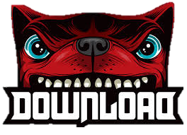

Angry dog could represent the type of music within the festival

Pointy font could resemble pointy guitars sometimes played by rock/metal musicians

Doesn’t tell the viewer it’s a festival

White text on a black background stands out well

Final D the opposite way around to make the writing more symmetrical

Red and black main colours

Bold Sans-Serif Font

Text could be hard to read

Dog main feature